General script for the semi-structured interview of clinic champions/leaders
“Thank you for meeting with me today. My plan for today is to do brief introductions, after which I will walk us through the 1-page overview of the value proposition for My Own Health Report, and do a brief demo of the tool, and then get your reactions”
Is it alright with you if I record our conversation today?
Clinic and Participant Characteristics Questions:
- Degree?
- What is your practice specialty?
- Year you finished your clinical training
- Number of Providers in your clinic?
- General age or type of patient you mostly see in your clinic?
- Approximate percentage of patients based on race or ethnicity does your clinic serve?
- General make up of insurance types covering patient population?
- EMR:

- Do brief introductions – give name and role
- Share screen to show the recruitment flyer
- Walk through the process of answering questions on www.myownhealthreport.org – show that the screen is available in English and Spanish, and answer questions to generate the report screen with a menu of answer choices
- Show the example 1-page report (Appendix 1)
Questions for interviews:
- What are your reactions?
- What do you think your clinic (clinics you work with) would see as the value/benefits for delivering My Own Health Report?
- Are there any headaches or pain points that your clinic is dealing with that would be addressed by My Own Health Report?
- What do you see as key challenges for delivering My Own Health Report?
  - Is there a subset of specific clinic team members who would be better suited to deliver this?
  - Are there specific patient populations that would raise the priority level?
- Who else should I talk to about this – is there anyone else in your organization or colleagues of yours who would be good to give input?

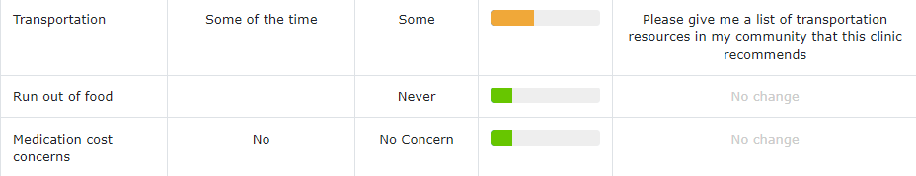
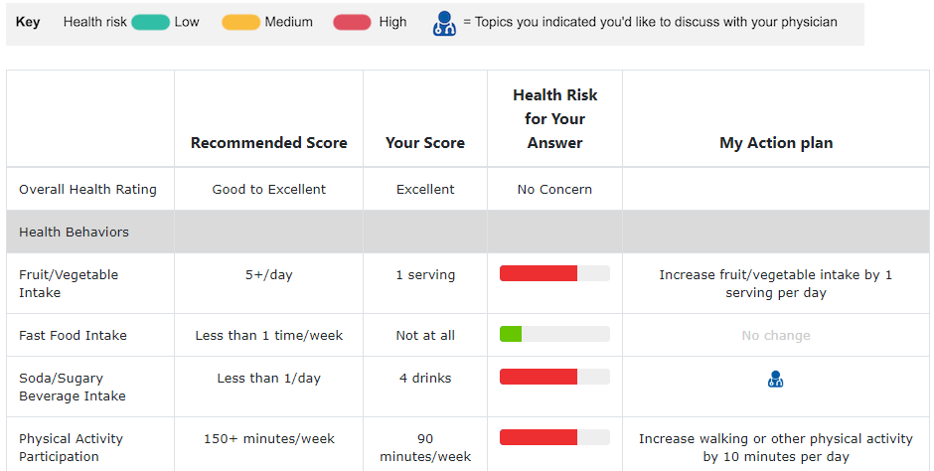
Appendix 1: example MOHR report

